AWS CLOUD PROJECT

AWS S3 Event-Driven Automation Using Lambda

Prepared by: _________ C TRISHA_________

1. Project overview
Event-driven automation starts a process automatically when a specific event occurs. In this project, an object upload to Amazon S3 can trigger an AWS Lambda function to process the uploaded file without a person manually starting the job.

2. Architecture and key concepts
- Amazon S3: holds incoming files, such as CSV documents.
- S3 event notification: detects object-created events and invokes the configured Lambda function. Prefix or suffix filters can limit which files trigger processing.
- AWS Lambda: runs code to validate, transform, or route the uploaded file, then writes results to an intended destination.
- IAM execution role: grants Lambda only the permissions required for the input, output, and logging operations.
- Amazon CloudWatch Logs: records execution messages and errors for troubleshooting.

3. Implementation workflow
Create an input bucket → create the Lambda function → configure the S3 object-created trigger → grant least-privilege permissions → upload a test file → inspect Lambda results and CloudWatch logs.

4. Reliability and troubleshooting
- Test with a small sample file and confirm that the event reaches Lambda.
- Check the Lambda execution role if the function cannot read the input object or write output.
- Use CloudWatch Logs to identify parsing errors, missing permissions, or unexpected input.
- Design for duplicate event delivery by making processing idempotent where possible.
- Prevent recursive invocation by writing output to a separate bucket or a prefix excluded from the trigger.

5. Security considerations
Do not store access keys or passwords inside the function code. Use the Lambda execution role and restrict access to the required S3 objects. Keep logs useful but avoid writing confidential data into them.

What I learned
I understood how S3 events and Lambda work together to automate file processing. Event-driven designs reduce manual effort, while IAM, logging, error handling, and duplicate-event protection make the workflow safer and more dependable.

Practical evidence to attach
Insert your own screenshots from the actual project in the spaces below. No screenshots from previous assignments have been copied into this report.
Screenshot 1: S3 bucket with the input file uploaded for testing.
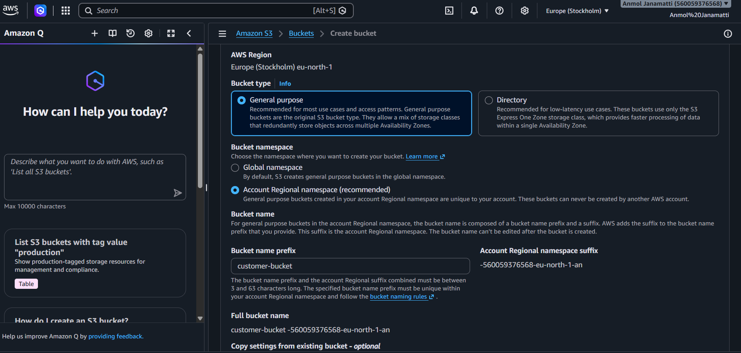
Screenshot 2: Lambda function configuration showing the S3 trigger/event source.
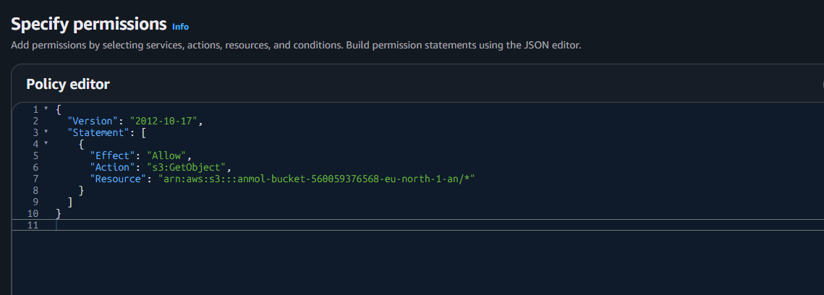
Screenshot 3: Successful test result or function execution details.
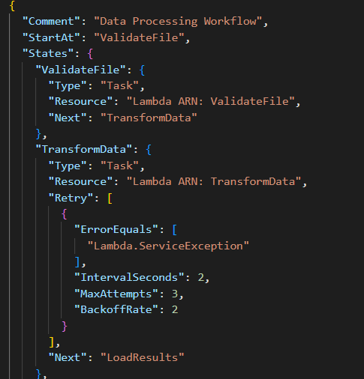
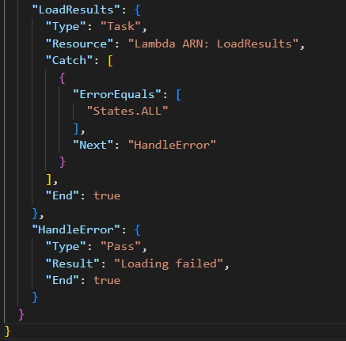
Screenshot 4: CloudWatch Logs showing the processing result or troubleshooting details.
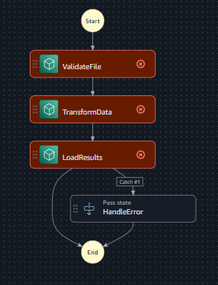

What I learned
I understood how S3 events and Lambda work together to automate file processing. Event-driven designs reduce manual effort, while IAM, logging, error handling, and duplicate-event protection make the workflow safer and more dependable.

